Use Case Document

for

UTDallas Computer Science

Degree Planner
Version 1.0
Prepared by Kainan Xu
University of Texas at Dallas
July 31, 2016

Table of Contents
1. Context Diagram 1
2. UTDallas Degree Planner Actor Descriptions 1
3. UTDallas Degree Planner Use Case Decriptions 2
4. Use Cases 2
4.1. Register 2
4.2. Login 3
4.3. Add Courses 5
4.4. Delete Courses 7
4.5. Register An Appointment 9
4.6. Create An Appointment 10
4.7. Modify Student Information 11

Context Diagram

The following figure shows difference types of users and use cases present in the degree planner system.
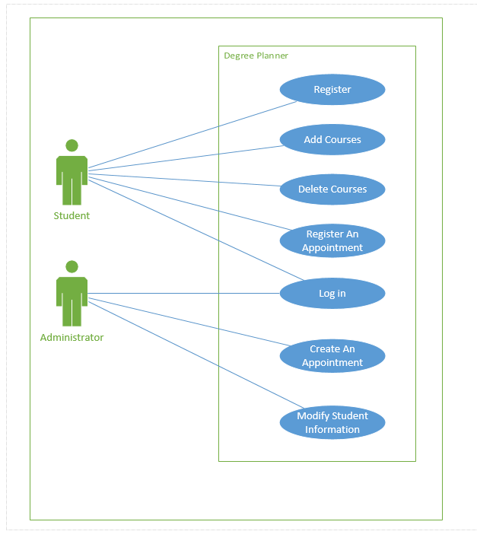

UTDallas Degree Planner Actor Descriptions

1.Student - a student from UTDallas and willing to add/drop courses and looking for information.
2.Administrator - a faculty of UTDallas and need to manage student information and arrange appointments.

UTDallas Degree Planner Use Case Decriptions

- Register - a student create an account in the system
- Log in - an existing user, include students and faculties, access the system with an id and password
- Add/delete Course - A student trying to add/delete a course for the next term
- Create/register An Appointment - A student or a faculty trying to create/register an appointment
- Modify Student information - A faculty trying to modify all kinds of students information, including add/drop courses, add/delete an appointment, change basic information and degree plan

Use Case 1: Register

Actor: Student users
Preconditions:
1. A new student who don’t have any account id or password.
Main success Flow:
1. The use case begins when the new student select Register button.
2. The student enter account id.
3. The student enter password.
4. The student confirm the password.
5. The student enter an email address.
6. The student enters an tel number.
7. The student click the confirm button.
8. System checks if the user information is valid.
9. The student successfully registered an new account.

Alternate Flows:
1. Users enter an invalid information, including wrong format, existing account id.

Post conditions:
1. Successful completion:
- The user will be redirected to the main information page.
2. Failure condition:
- An alert windows will be shown to indicate users the part of the invalid information.

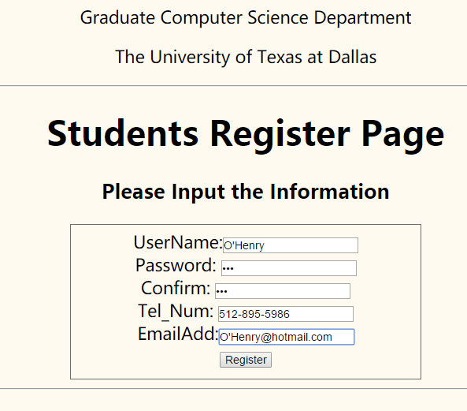
Figure 1. Screen shot for student register page

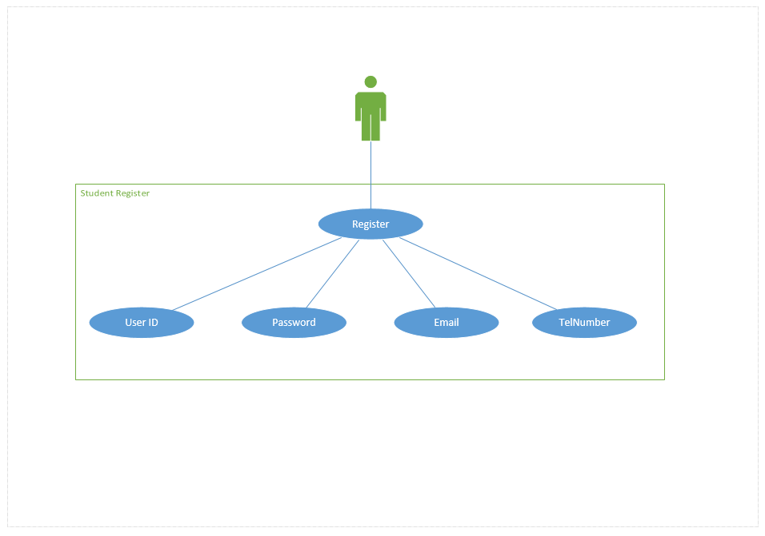
Figure 2: Use Case diagram for register

Use Case 2: Log In

Actors: Student, Administrator
Preconditions:
1. A user with valid account to access the degree planner system.
Main success Flow:
1. The use case begins when a user with a valid account and password.
2. The user enter account id.
3. The user enter password.
4. System verify the combination of account ID and password.
5. The user case ends successfully.

Alternate Flows:
1. Users enter an invalid information.

Post conditions:
1. Successful completion:
- The user will be redirected to the main information page.
2. Failure condition:
- An alert windows will be shown and the user will be redirected to the main page for re-entering account information.

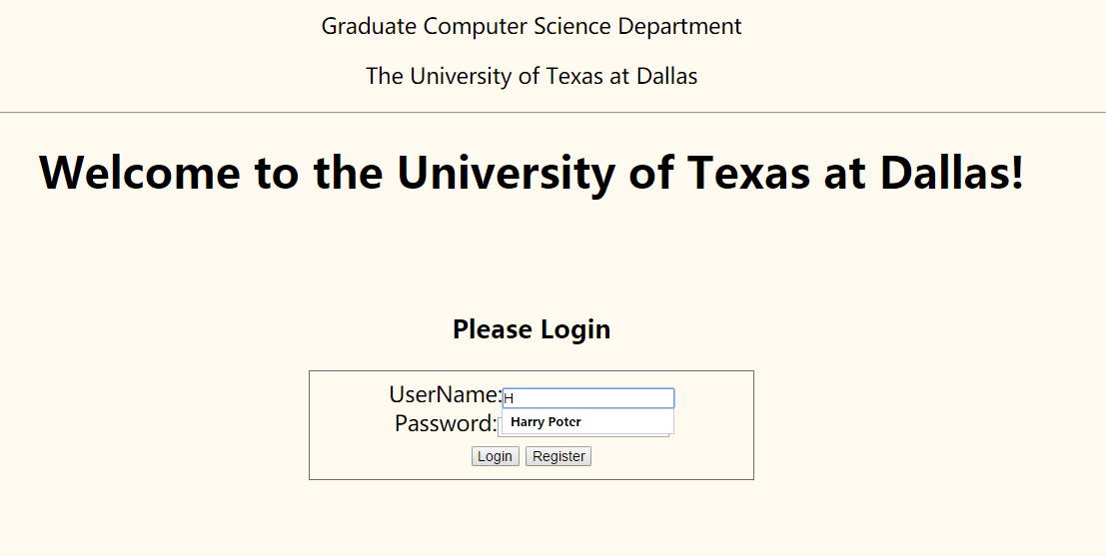
Figure 3. Screen shot of log in page

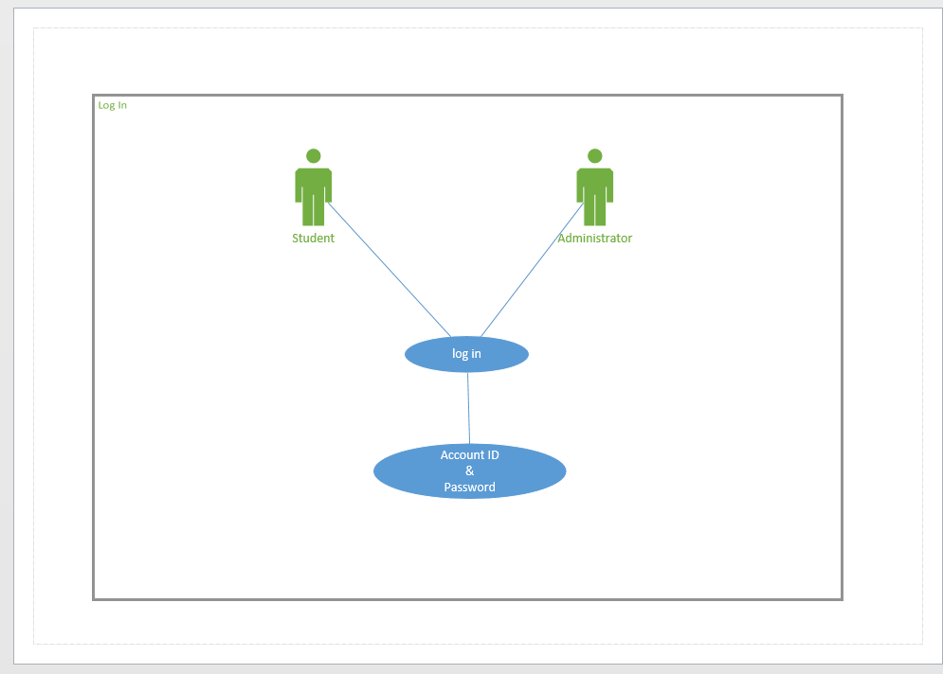
Figure 4. Use Case diagram for login

Use Case 3: Add Courses

Actors: Student, Administrator
Preconditions:
- A user with valid account to access the degree planner system, for a student, the page will be redirected to the main information page, for an administrator, the page will be redirected to the main management page.

Main success Flow:
- The use case begins when users select an core course or an elective course based on their track.
- The user click submit to confirm their selection.
- The system will pop up an alert window to confirm user the success.
- The use case ends successfully.

Alternate Flows:
1. The user selected a core course when there is already a core course be selected.

Post conditions:
1. Successful completion:
- An new record will be insert into the database system.
2. Failure condition:
- An alert windows will be shown to indicate the failure, the system will remain unchanged.
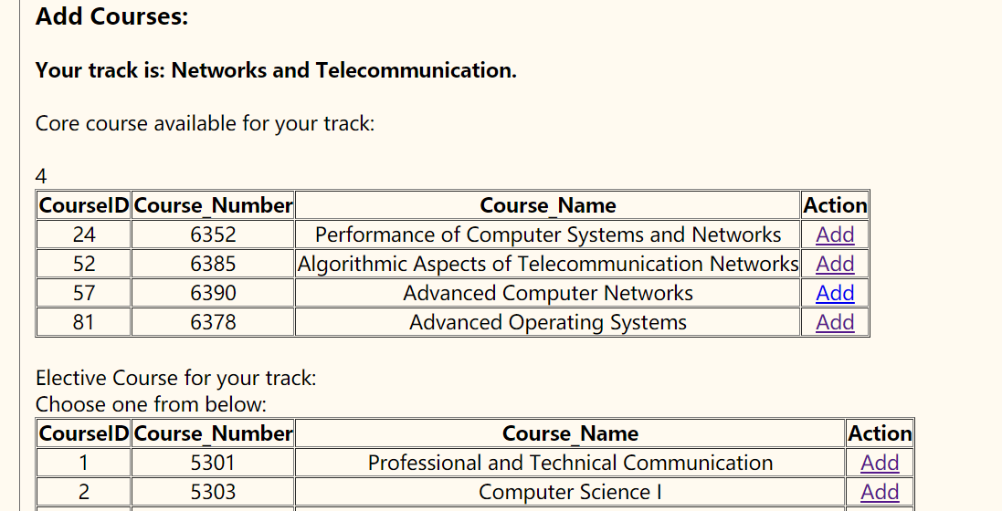
Figure 5. Screen shot for add course

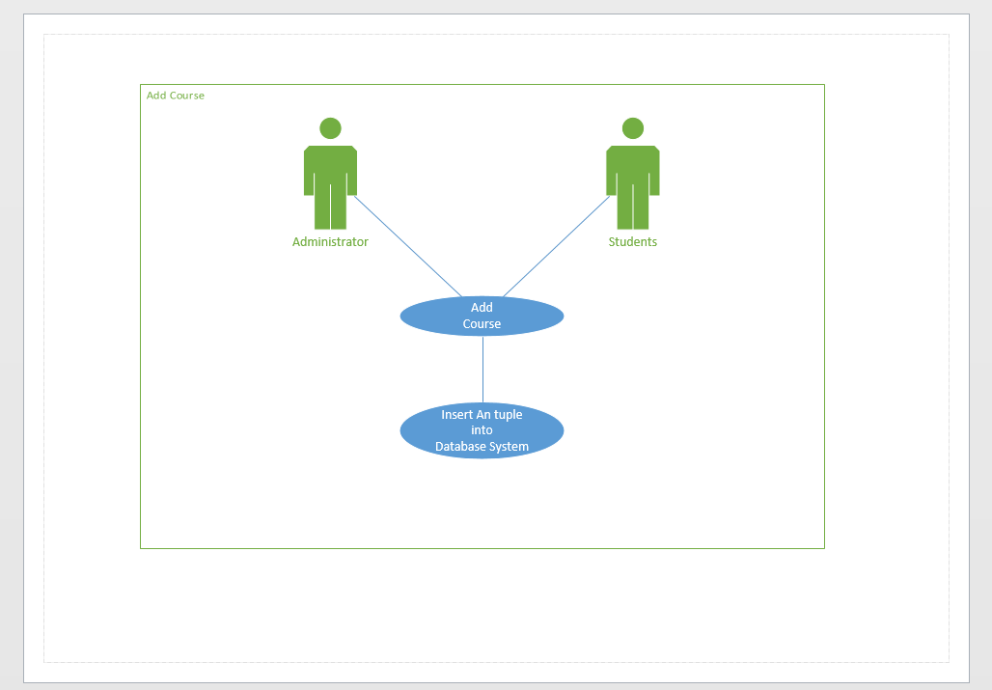
Figure 6. Use Case diagram for add course
Use Case 4: Delete Courses

Actors: Student, Administrator
Preconditions:
- A user with valid account to access the degree planner system, for a student, the page will be redirected to the main information page, for an administrator, the page will be redirected to the main management page.

Main success Flow:
- The use case begins when users enters the main information page.
- The user select a desired course to delete.
- The system will pop up an alert window to confirm user the success.
- The use case ends successfully.

Alternate Flows:
1. System fail to update the database for some reasons.

Post conditions:
1. Successful completion:
- An new record will be insert into the database system.
2. Failure condition:
- An alert windows will be shown to indicate the failure, the system will remain unchanged.

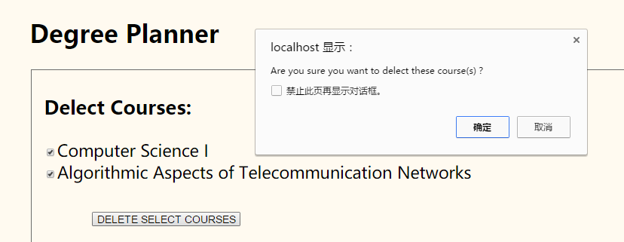
Figure 7. Screen shot for delete courses

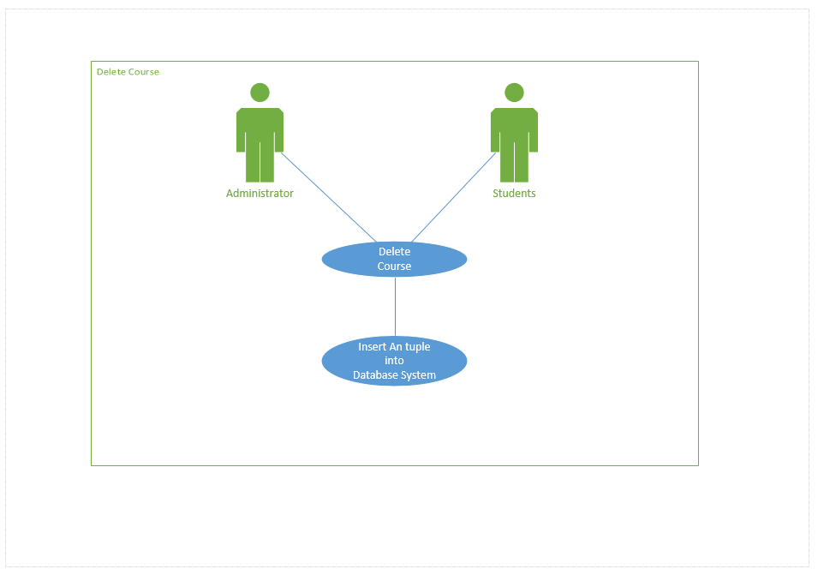
Figure 8. Use Case diagram for delete courses

Use Case 5: Register An Appointment

Actors: Student
Preconditions:
- A student with valid account to access the degree planner system, for a student, the page will be redirected to the main information page.

Main success Flow:
- The use case begins when users enters the main information page.
- The user select a desired time and adviser to register an appointment.
- The system will pop up an alert window to confirm user the success.
- The use case ends successfully.

Alternate Flows:
- The user try to make an appointment while he has already registered an appointment or he has already registered with this adviser.

Post conditions:
1. Successful completion:
- An new record will be insert into the database system.
2. Failure condition:
- An alert windows will be shown to indicate the failure, the system will remain unchanged.

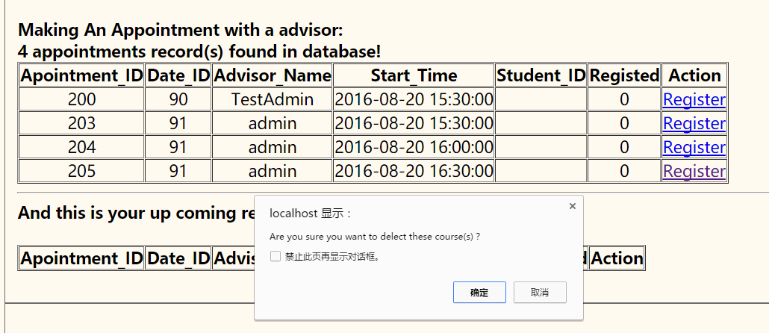
Figure 9. Screen shot for register an appointment

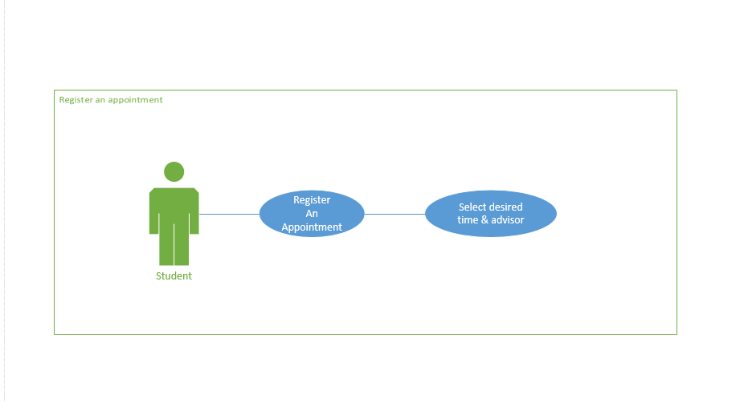
Figure 10. Use Case diagram for register an appointment

Use Case 6: Create An Appointment

Actors: Faculty
Preconditions:
- An administrator with valid account to access the degree planner system, the page will be redirected to the main management page.

Main success Flow:
- The use case begins when users enters the main information page.
- The user select a desired time period to register for an appointment.
- The system will pop up an alert window to confirm user the success.
- The use case ends successfully.

Alternate Flows:
- The user try to make an appointment while he has already create an appointment or he is trying to create an appointment which duration is more than one day.

Post conditions:
1. Successful completion:
- An new record will be insert into the database system.
2. Failure condition:
- An alert windows will be shown to indicate the failure, the system will remain unchanged.

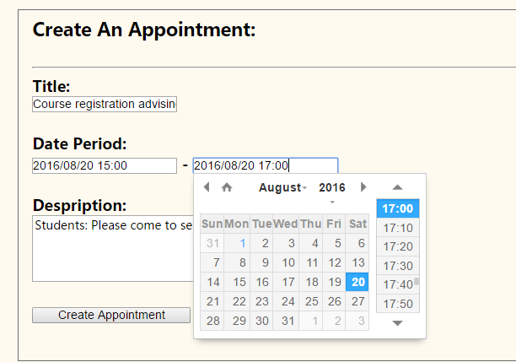
Figure 11. Screen shot for create an appointment

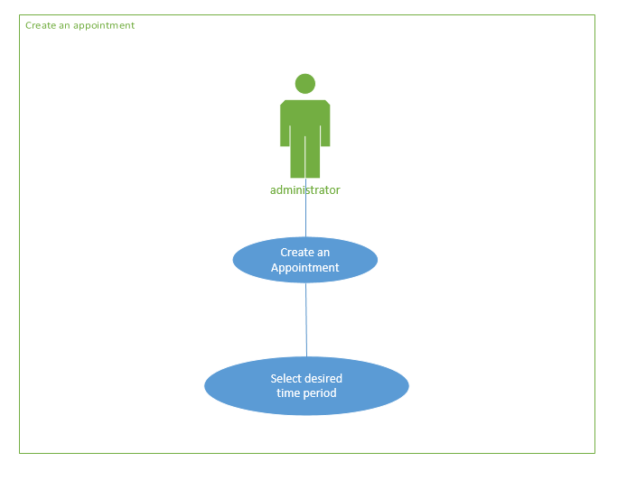
Figure 12. Use Case diagram for create an appointment

Use Case 7: Modify student information

Actors: Faculty
Preconditions:
- An administrator with valid account to access the degree planner system, the page will be redirected to the main management page.

Main success Flow:
- The use case begins when users enters the main information page.
- The user select an information that he is going to change.
- The user click the change button to modify the information in a new page.
- System pop up an window to indicate user the success and back to the main management page.
- The use case ends successfully.

Alternate Flows:
- The use case begins when users enters the main information page.
- The user select an information that he is going to change.
- The user click the change button to modify the information in a new page.
- System fail to update the database due to some reasons.

Post conditions:
1. Successful completion:
- An new record will be insert into the database system.
2. Failure condition:
- An alert windows will be shown to indicate the failure, the system will remain unchanged.

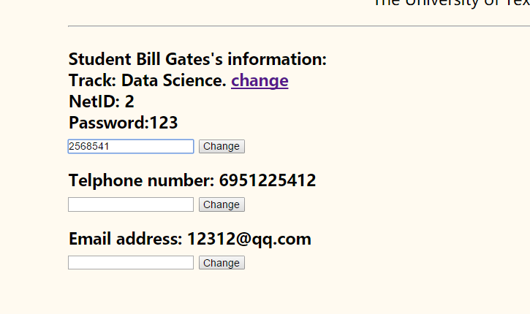
Figure 13. Screen shot for student information modify

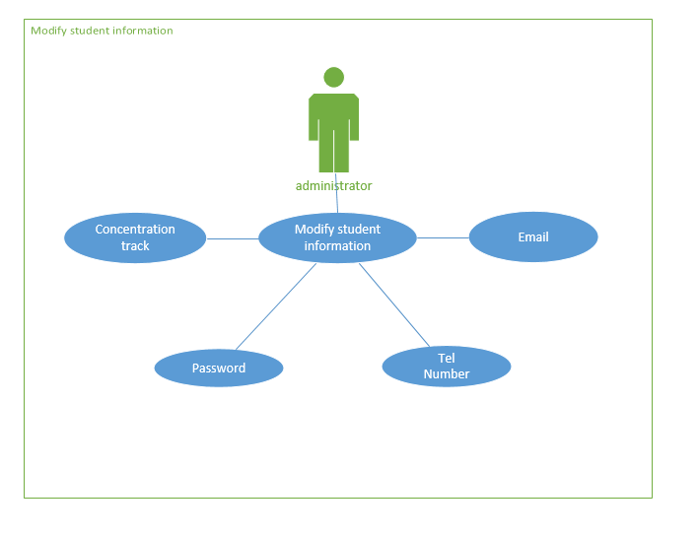
Figure 14. Use Case diagram for modify student information

Revision History
Name | Date | Reason for Changes | Version
Kainan Xu | July 18, 2016 | Initial draft | 1.0 draft 1
Kainan Xu | July 26, 2016 | Fix some typesetting issues | 1.0 draft 2
Kainan Xu | July 31, 2016 | Finalize documentations | 1.0

